**UNV Practical Questions 2019**

Please take look at the attached Excel sheet listing some projects undertaken by UNEP and answer the following questions. (Time limit: 2 days)

1. Normalize the data in the Excel and show relationships between the derived tables, if any. *Use of primary keys, foreign keys etc. is strongly encouraged.*

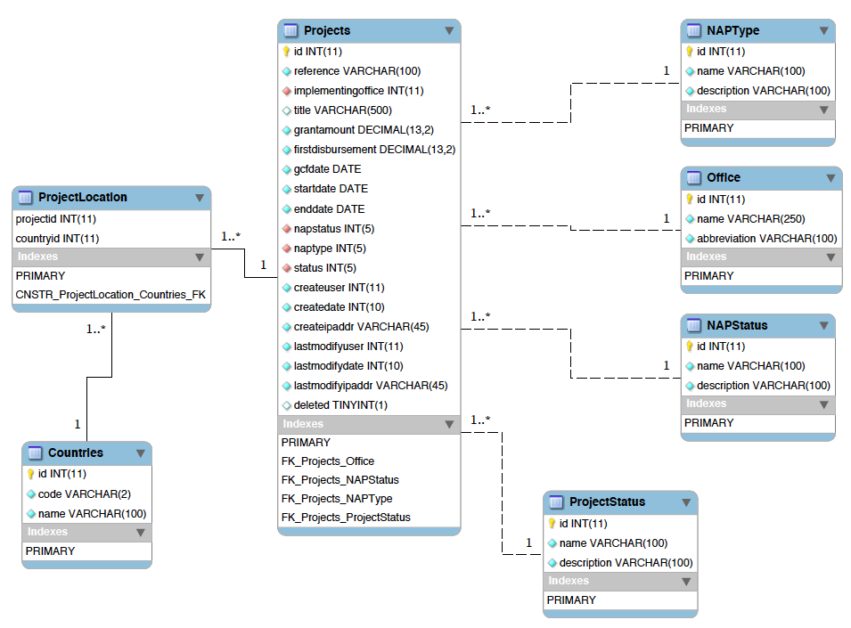

*(Refer to 01. ERD Diagram (detailed) - UNEP Assignment.pdf for clear image)*

1. Create a web interface (using HTML forms) that can be used to manage these projects i.e. add, edit and delete projects (CRUD functionalities). *For the sake of time, only the project’s table needs to have an interface for CRUD operations. The other derived tables can be managed from the backend.*
2. Use of front-end libraries and frameworks like Bootstrap, FontAwesome, VueJS, AngularJS, ReactJS, etc. is strongly encouraged but not necessary.

I made use of an opensource admin dashboard and control panel theme (https://adminlte.io/). The theme makes use of various JavaScript libraries amongst which include Bootstrap3 and FontAwesome

1. The back-end should be done using PHP, Python, NodeJS or any other web programming language that runs on a Linux environment. Use of frameworks like PhalconPHP, Laravel, Django, ExpressJS is strongly encouraged, but not necessary.

I have done the backend with CodeIgniter MVC framework which was for quick rapid deployment

1. The database can be MySQL, MariaDB, SQLite, MongoDB or any other Database system that runs on a Linux environment.

I am running the database of MySQL

1. Create a page that lists these projects in a tabular format.
2. The table should display 10 rows per page by default, but with the option of allowing the user to choose the number of rows to display e.g. 5, 20, 50, all etc.

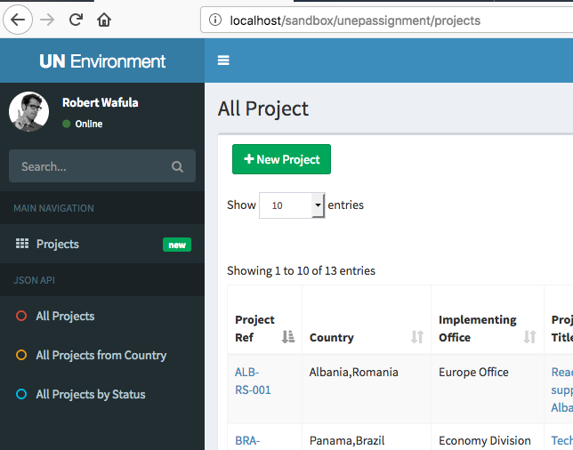

1. There should be a pager at the bottom of the page showing the current page number e.g. page 3 of 5 or something similar.

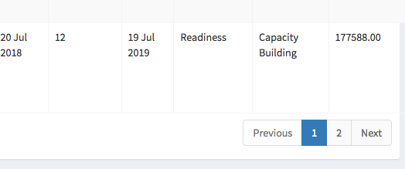

1. For each record, there should be a column for actions (view, edit, delete) which when clicked allows the user to view the record in detail, edit the record or delete the record.

* To view or edit: you can click on the project reference or project title
* There is an update button that edits the record once you are in it, and a delete button to erase the record
* There is also an edit button from the listing at the far right that also opens the record for viewing or editing
* There is also a delete button that you can delete a record from the list without having to open the record

1. Create an API that exposes the above projects as JSON. The API endpoints can work as explained below:
2. Navigating to a URL like *api/projects/all* will return all projects as JSON
3. Navigating to a URL like *api/projects/country/kenya* will return all projects from country Kenya as JSON
4. Navigating to a URL like *api/projects/status/completed* will return all projects with status completed as JSON

* All the above are done, and can be opened directly from the left menu as shown

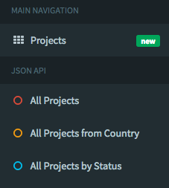

* The API allows space characters so as to enable calling of records that may have a space character in the name such as the status ‘under implementation’

1. **Important**: Share your source code, database dumps and **instructions on how to install your application** via **GitHub, GitLab or Bitbucket**
2. Please be as creative as possible

Good Luck